# **Exercise 4: Creating and Configuring a Maven Project**

## **Scenario**

You need to set up a new Maven project for the Library Management application and add Spring dependencies for backend development.

## **Step 1: Create a New Maven Project**

* Created a new project folder named LibraryManagement.
* Opened the folder in VS Code (or any IDE).

## **Step 2: Add Spring Dependencies in pom.xml**

Added the required Spring modules:

* Spring Context for IoC and Dependency Injection
* Spring AOP for aspect-oriented programming
* Spring WebMVC for building web applications

<dependencies>  
 <!-- Spring Context -->  
 <dependency>  
 <groupId>org.springframework</groupId>  
 <artifactId>spring-context</artifactId>  
 <version>5.3.30</version>  
 </dependency>  
  
 <!-- Spring AOP -->  
 <dependency>  
 <groupId>org.springframework</groupId>  
 <artifactId>spring-aop</artifactId>  
 <version>5.3.30</version>  
 </dependency>  
  
 <!-- Spring WebMVC -->  
 <dependency>  
 <groupId>org.springframework</groupId>  
 <artifactId>spring-webmvc</artifactId>  
 <version>5.3.30</version>  
 </dependency>  
</dependencies>

## **Step 3: Configure Maven Plugins**

Added the Maven Compiler Plugin to ensure the project uses Java version 1.8:

<build>  
 <plugins>  
 <plugin>  
 <groupId>org.apache.maven.plugins</groupId>  
 <artifactId>maven-compiler-plugin</artifactId>  
 <version>3.11.0</version>  
 <configuration>  
 <source>1.8</source>  
 <target>1.8</target>  
 </configuration>  
 </plugin>  
 </plugins>  
</build>

## **Final pom.xml**

<project xmlns="http://maven.apache.org/POM/4.0.0"  
 xmlns:xsi="http://www.w3.org/2001/XMLSchema-instance"  
 xsi:schemaLocation="http://maven.apache.org/POM/4.0.0  
 http://maven.apache.org/xsd/maven-4.0.0.xsd">  
  
 <modelVersion>4.0.0</modelVersion>  
  
 <groupId>com.library</groupId>  
 <artifactId>LibraryManagement</artifactId>  
 <version>1.0-SNAPSHOT</version>  
  
 <dependencies>  
  
 <!-- Spring Context -->  
 <dependency>  
 <groupId>org.springframework</groupId>  
 <artifactId>spring-context</artifactId>  
 <version>5.3.30</version>  
 </dependency>  
  
 <!-- Spring AOP -->  
 <dependency>  
 <groupId>org.springframework</groupId>  
 <artifactId>spring-aop</artifactId>  
 <version>5.3.30</version>  
 </dependency>  
  
 <!-- Spring WebMVC -->  
 <dependency>  
 <groupId>org.springframework</groupId>  
 <artifactId>spring-webmvc</artifactId>  
 <version>5.3.30</version>  
 </dependency>  
  
 </dependencies>  
  
 <build>  
 <plugins>  
 <plugin>  
 <groupId>org.apache.maven.plugins</groupId>  
 <artifactId>maven-compiler-plugin</artifactId>  
 <version>3.11.0</version>  
 <configuration>  
 <source>1.8</source>  
 <target>1.8</target>  
 </configuration>  
 </plugin>  
 </plugins>  
 </build>  
  
</project>

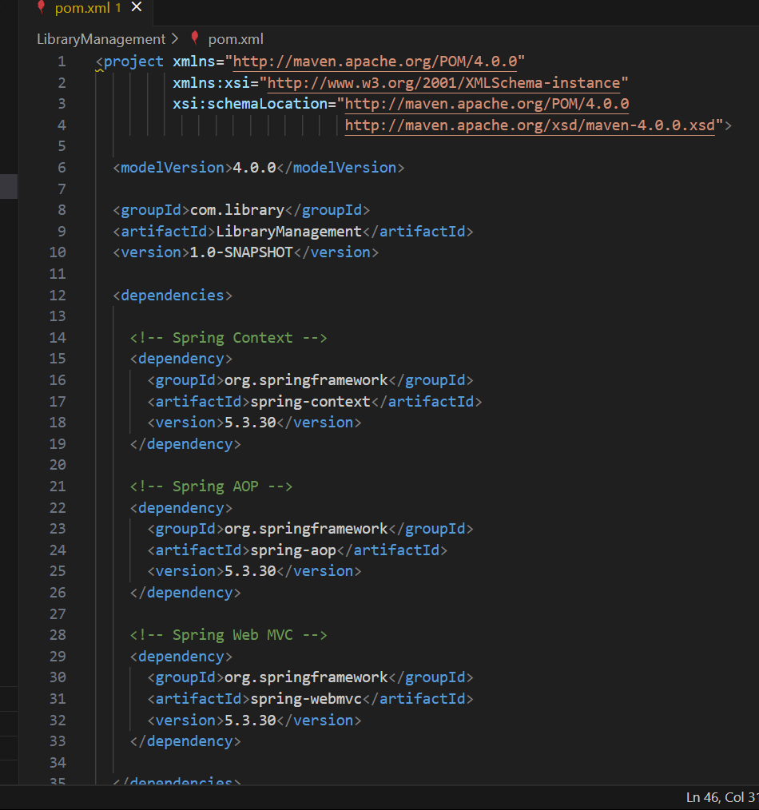

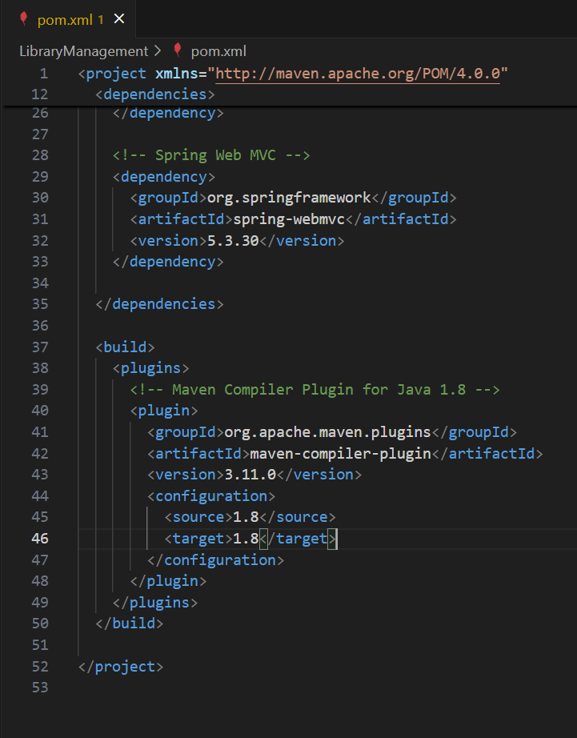

How I Verified

Ran the Maven compile goal:

mvn compile

Output:

[INFO] BUILD SUCCESS  
[INFO] Nothing to compile - all classes are up to date

This confirms that Maven and Spring dependencies are set up correctly and ready for further development.

